The Microsoft Office Graphics Program
Add Impact to All Your Business Communications
Create the professional look you want for your Web site, printed documents, and presentations using Microsoft Photodraw 2000 Version 2 business graphics software. PhotoDraw combines easy-to-use image-editing and drawing tools in a single powerful program that enables Microsoft Office business users to enhance their communications using photos, shapes, text, and special effects, and get professional-looking results every time.

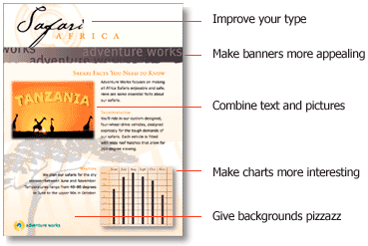

Create Graphics for All Your Needs
PhotoDraw 2000 makes it easy to optimize and save graphics in appropriate formats for the Web, print, and presentations so you can create a unified look for all your communications. For example, use your company's logo in your Microsoft FrontPage® Web site, on the cover of a printed catalog created in Microsoft Publisher, in a fact sheet created in Word, and in a Microsoft PowerPoint® presentation.

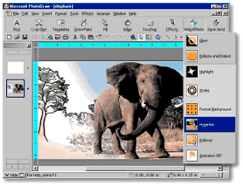

Learn more about these topics in the PhotoDraw 2000 Version 2 tour:
- All the Tools You Need in One Application
- Start Fast and Stay on Track
- Create Eye-Catching Web Graphics
- Share Your Graphics with Other Microsoft Office Applications
- Experience PhotoDraw
- System Requirements and Pricing
All the Tools You Need in One Application
With Microsoft PhotoDraw 2000 you can streamline graphics creation by working on photos, clip art, drawings, shapes, and text with the same tools and at the same time. And you can combine photos, text, and other effects such as 3-D into a single, highly effective graphic.

Enhance Your Own Images or Work with Ours
Import your own photos or select from our library of 20,000 images and pieces of clip art. Customize standard clip art by adding a photo, or using easy-to-apply artistic brushes and colors.

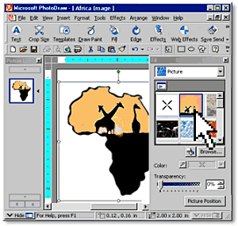

Powerful photo-editing and touch-up tools include one-click automatic color correction and dust-and-scratch removal to help you make any photo fit for publication.

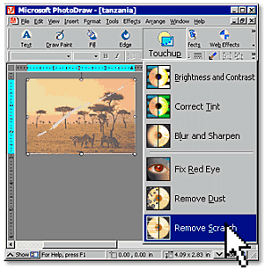

Express Your Graphic Ideas by Drawing Them
Create the perfect image using advanced drawing tools. A single mouse-click applies just the right effects, such as the artistic brush shown below. Choose from 200 built-in special effects and styles—including new embed, emboss, highlight, and glow—in multiple resolutions so your creation looks great online and in print.

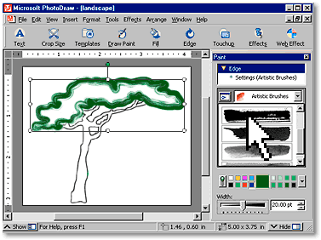
Start Fast and Stay on Track
Microsoft PhotoDraw 2000 is designed to get you up and running quickly, and then help you stay productive. Step-by-step wizards and easy-to-apply point-and-click effects save you time by simplifying common graphics tasks. And flexible templates help you create a wide range of projects, from Web buttons to flyers.

Rely on Built-in Design Expertise Right from the Start
Jump-start your projects and speed your work with more than 450 professionally designed templates and content. Get step-by-step assistance while you create your design.

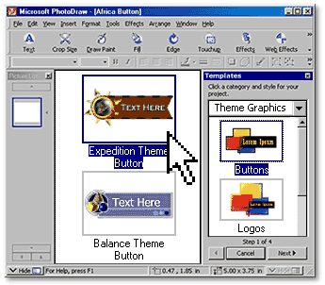

Save Your Graphics Without the Guesswork
Automatically save your graphics in the optimal format for the Web, print, or presentations with the Save for Use In Wizard. Preview graphic size, download time, and image quality for professional results. You can also automatically save or convert all your open graphics to a different format in one quick batch process.

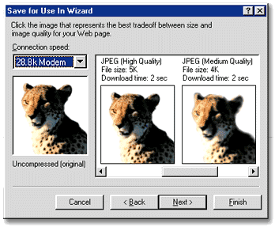

Quickly Apply Formatting
Create a custom look and then easily apply it to any object using the Format Painter tool. Just select the object whose formatting you want to copy, click on the Format Painter icon, and then click on a different object. It's that simple.

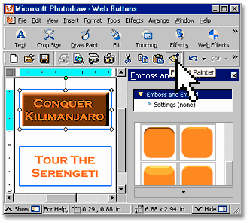
Create Eye-Catching Web Graphics
Work with an array of tools to help you create banners, GIF animations, image maps, and rollover buttons for attractive and dynamic Web graphics. Jump-start your Web graphics projects by choosing from a variety of new Web graphic templates or create your own. Take advantage of HTML by opening and editing Web graphics from within your Web browser. And, use automatic image slicing to decrease graphic size and create space on Web pages. Preview your work in a Web browser to see how your creation will appear on your site.

Get Attention Quickly with One-Click Animation
Bring your Web pages to life with easy-to-apply GIF animations.

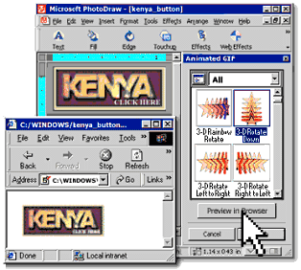

Easily Add Web Button Rollover Effects
Create dynamic Web graphics such as rollover effects that include highlighting and color changes. Easily export them for use in Microsoft FrontPage® 2000, and use Web-safe color palettes.

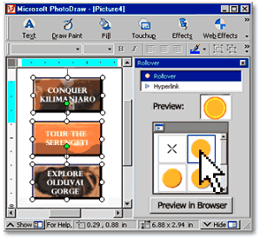
Share Your Graphics with Other Microsoft Office Applications
Add impact to your documents and presentations and give all your projects a consistent look. Customize your Web pages, documents, and presentations by mixing PhotoDraw graphics with themes and color schemes from Microsoft FrontPage®, Word, the PowerPoint® presentation graphics program, and Publisher.

Enhance Communications Created Using Office
Use graphics created in PhotoDraw to enhance flyers, newsletters, catalogs, documents, and Web pages created Office applications.

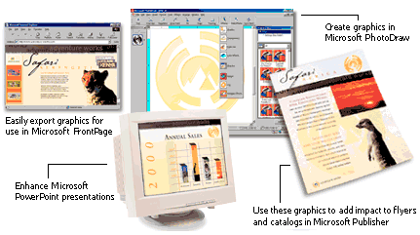

PhotoDraw 2000 Works Like Microsoft Office
If you know how to use Microsoft Office, you'll be right at home with PhotoDraw 2000. Rely on the familiar Office toolbar and help files. Install PhotoDraw easily using standard Microsoft Office 2000 installation procedures. And easily store and share your graphics by saving to a Web server.

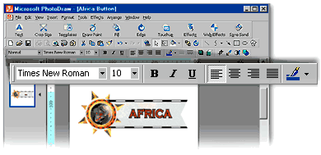

Easily Send Your PhotoDraw Graphics Directly to Other Office Applications
Simplify your workflow. Automatically save and send your graphics to FrontPage 2000 or PowerPoint 97 or later.

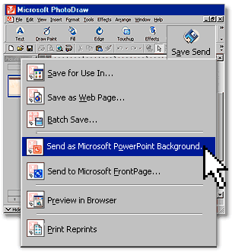

Quickly Build Web Pages Using PhotoDraw with FrontPage 2000
Send PhotoDraw graphics directly to FrontPage 2000, and then easily use PhotoDraw 2000 Version 2 to edit graphics within your FrontPage Web site.

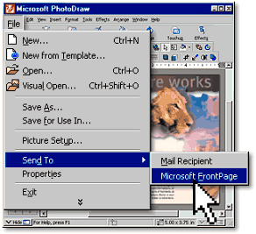

Experience PhotoDraw 2000
Try PhotoDraw 2000 Version 2 for yourself. To experiment with different Designer Effects, move your mouse over one of the effects icons. Click on it to apply the effect to the button. Try them all!

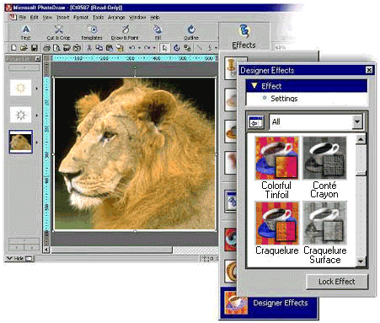

Try Out All the Features of PhotoDraw in the 30-Day Trial
Order the 30-Day Trial to see how Microsoft PhotoDraw 2000 Version 2 can add impact to all your business communications:
- Photo editing and touch up photos
- Natural brushes, photo brushes, and stamps
- Vector drawing
- Clip-art restyling
- 3-D effects
- Format painter
- Output for the Web, print, or presentations
- Batch save
- Web graphic optimization
- Easy Web editing—open, edit, and save images on HTML pages
- Image maps, rollover effects, and GIF animations
- Program compatibility—import CorelDRAW 3 or later and Photoshop graphics
- 20,000 pieces of high-quality content and clip art
- 50 built-in Web effects and styles
- 450 professionally designed templates
- 400 shapes (includes 198 AutoShapes)
- 500 tileable textures
- 300 strokes, stamps, and edges
- 200 designer effects
- 22 file import filters
- Scanning
- Direct connection for digital cameras
- Built-in Tutorial and user tips
- Microsoft Office compatibility—Easily share graphics across Microsoft Office applications
System Requirements and Pricing

Below you'll find the system requirements and pricing information for Microsoft PhotoDraw 2000 Version 2.

System Requirements
To use Microsoft PhotoDraw 2000 Version 2, you need:

- PC with Pentium 166 MHz or higher processor
- Microsoft Windows® 95 or later operating system, or Microsoft Windows NT® Workstation operating system version 4.0 or later with Service Pack 2 or later
- For Windows 95 or Windows 98:
- 16 MB of RAM for the operating system, plus an additional 16 MB of RAM for PhotoDraw
- For Windows NT Workstation version 4.0:
- 32 MB of RAM for the operating system, plus an additional 16 MB of RAM for PhotoDraw
- Available hard-disk space (Numbers indicate typical installation; your hard-disk usage will vary depending on configuration. Choices made during custom installation may require more or less hard-disk space):
- For systems with any Office 2000 application installed: 115 MB of available hard-disk space; for optimal performance, an additional 100 MB of available hard-disk space for user graphics and temporary image caches recommended
- For systems without an Office 2000 application installed: 190 MB of available hard-disk space; for optimal performance, an additional 100 MB of available hard-disk space for user graphics and temporary image caches recommended
- CD-ROM drive
- Super VGA monitor; 1 MB of VRAM
- Microsoft Mouse, Microsoft IntelliMouse®, or compatible pointing device

Additional items or services required to use certain features:

- 14,400 baud modem; 28,800 or higher-baud modem recommended
- Multimedia computer required to access sound and other multimedia effects
- Some Internet functionality may require Internet access and payment of a separate fee to a service provider and local charges may apply

Compatible with:

- MIX, FPX, JPEG, PCD, TIFF, WMF, BMP, CDR, GIF, PCX, PNG, TGA, EPS, PSD, and more file formats
- TWAIN digital cameras and scanners

Pricing and Ordering
Microsoft PhotoDraw 2000 Version 2 business graphics software is now available for an estimated retail price of $109 US/$159 CAN and includes a $20 US/$30 CAN rebate coupon for current users of Microsoft Office 97 or later, Microsoft FrontPage® 97 or later, or CorelDRAW6 or later.
For additional pricing information, visit the Office retail pricing page.

Get PhotoDraw and More in Office 2000
Get even more out of PhotoDraw when you get it as part of a Microsoft Office 2000 suite. See what's in each suite below, or find out which suite is right for you. If you're a software developer, you'll find information for you at the Office 2000 Developer Web site.

